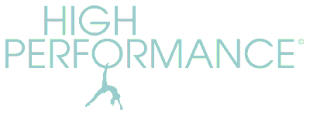
DECEMBER 2020 ZOOM CLASSES
Online classes remain PAYG at £7.50 per class and are open to all clients.
Private Zoom sessions available on request by arrangement and cost £30.

TUESDAY 10am
4pm
WEDNESDAY 10.30am
6.30pm
FRIDAY 10am

Home visits and studio classes are currently suspended until further notice.
Studio 1:1’s will be available if restrictions allow.

